JOHNS SANDWICH SHOP.

DATBASE - an organized collection of information stored and accessed electronically mainly from a computer system.

PURPOSE AND BENEFITS.

Developing a database for the business will help in:

* Making data management simple and efficient
* Analyse data in a variety of ways
* Encouraging a disciplined approach to data management
* Turn information into a valuable resource
* improving the quality and consistency of information

Requirements

1. Forms to enter information about customer, Order, Sandwich and the shop
2. User to open all forms, queries and reports.
3. A report that displays all order that still require payment for outstanding orders.
4. A report that displays an invoice for a particular customer invoice.

**NOTE: 10% discount is given to the customers when they spend over £50**

**Design requirements**

A consistency of styling must be employed in order to create a professional image and to help users interact with the system. Consistency must extend to at least the following:

* Layout Inc. forms, reports and use of logos etc.
* Colours
* Naming of tables and fields

Meeting discussion

* In the meeting I attended with the Sandwich Maker, Clerk, Customer Driver and the Manager we discussed about their roles and the new project which will bring changes to the computer system, staff and the business in general since three new branches will be opened soon due to a popular demand. They have raised issues that can be solved moving forward. The meeting highlighted that a real change was needed.

What do People do in Mia’s Sandwich Shop?

Customer role.

The Customer orders a Sandwich. (Buys a service and product) giving their Name, Address, Postcode, Contact Number and billing information by filling the customer form Uses a menu to evaluate their choices. Passes the information to clerk.

Order clerk.

Takes and process customer order ensure there are supplies in stock. Receives Customers Names, Addresses, postcode, billing information and contact number. Gives information on Price and data related to the transaction. Process the information given and insert it in the order form and Passes information to Manager.

Sandwich Maker role.

Creates and presents sandwich to each Customer gives information if order made will be achievable Receives Information on stock and suppliers to determine what is possible to create and make and gives recommendation to the order clerk. Fills the sandwich form.

Driver Role.

Loads transports and delivers items to customers in a safe, timely manner. He also reviews orders before and after delivery to ensure that orders are complete, the charges are correct, and the customer is satisfied. Takes payments for delivered items and prepares reports and other documents relating to deliveries.

Problems.

1. Errors being made when inserting data
2. Retrieving Data
3. No reporting facilities causing lack of printing invoice and outstanding payments.
4. Spreadsheet use not effective
5. Communication between order clerk and sandwich maker being inadequate due to sandwiches being made and later cancelled due to change from the customer or wrong order from the clerk which leads to food being wasted causing profit loss.
6. Lack of organization
7. Delivering food to the wrong addresses since the customers don’t enter the correct address due to the system not having restricted choices to avoid this problem
8. Lack of contribution from other staff members causing delays leading to customers complaining since the delays affect the whole business.
9. Widespread system problems from all the staff.
10. Layout that’s not welcoming to customers and causes crowding of the business.
11. Errors being made when counting inventory
12. Theft of cash during night-time.
13. Staff not having basic knowledge in language and literacy

Recourses

1. New up-to-date computers across all the business operation rooms.
2. Scanners.
3. Multiple contactless card readers.
4. Cash wrap/point of sale (POS) to be integrated-to avoid lines and crowding.
5. Digital signage equipment.
6. Cameras/security.

Limitations of the project.

1. Training of staff will be needed in order to enhance communication, cooperation, cash handling and use of the database and computers.
2. Low Budget.
3. Enlightening and educating customers on how their data will be used.
4. New design and layout to be made in all shops to give the customers and staff smooth experience.
5. New recruitment process so that the business can progress and be successful.
6. Additional resources.

Proposals.

1. Unique ids to easily find information.
2. Data dictionary to be active.
3. Primary keys to be used.
4. Training staff
5. Create reports, queries and forms.
6. 10% discount to be applied on orders above £50
7. Changing the interior of the stores

After the discussions, I made an Entity relationship diagram to design and model the database. This is the basic first step to build a database. Microsoft Access is used to design, implement and maintain the database It contains different table including.

* Customer Table this table has information about unique Id that gets generated when customer name, surname, address, postcode, Sex, DOB, Time ordered, Order payment. This data is used to Identify and categorize the customer age and contact information for deliveries.
* Order table has a unique id that contains information that classifies the order, who made it both customer and staff, time and date the order was made and the delivery id and most importantly the mode payment.
* Staff table-Includes all necessary contact information on staff, date of employment, position and qualification and comes with the unique id which instantly identifies the staff.
* Delivery table has information on the customer and staff delivery, time and date ordered and contact details of customer and staff helping the delivery to be delivered in a simple and easy way.
* Sandwich table holds information of the sandwich name, type, Description which says the ingredients and how it was made and price.
* Branch Table has information on the branch's location, address and contact details. Each branch also has a unique id which gives all the information needed.

Normalised 3rd order form entity relationship diagram. 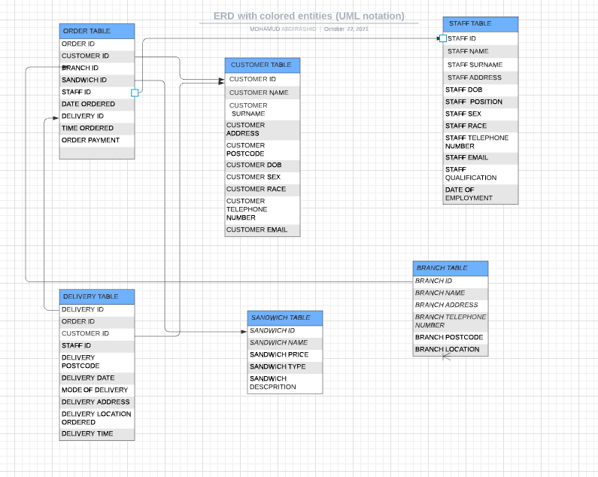

Forms

* Customer Form will be used to insert customer information by the customer when ordering and staff uses it to confirm if it has the data.
* Staff Form will be used to put in the detail of staff and filled when they come to work and leave this will be overseen and filled by the manager.
* Order form will be filled by the customer and staff so that the order can take place and it has information on contact details and if the payment is paid or not.
* Delivery form is to be filled by the staff and signed by the customer to confirm if the order has been delivered.
* Sandwich form will be filled by the order clerk and sandwich maker detailing the inventory, sandwich description and price.

Report

Reports will offer the shops a way to view, format, and summarize the information in the database. The tool used will be report wizard which displays a multiple-step wizard that lets you specify fields, grouping or sorting levels and layout options. The Aim is to display all order that still require payment for outstanding orders. Also, a report that displays an invoice for a particular customer invoice.

Query

Select query will be suitable to review data from a certain field in a table, or maybe just see the data based on certain criteria. This will apply to categorically view customer payment if it is paid or outstanding and show the discount available.

DATA DICTIONARY.

Data dictionaries are used to provide detailed information about the contents of a database for example metadata and also restricts what information the customers and staff can insert to avoid mistakes I propose that it should be active so that it can be maintained as new customers join the and the information increases However, for this to take place we need a skilled database worker who will also provide training for staff on how to use and utilise the database.

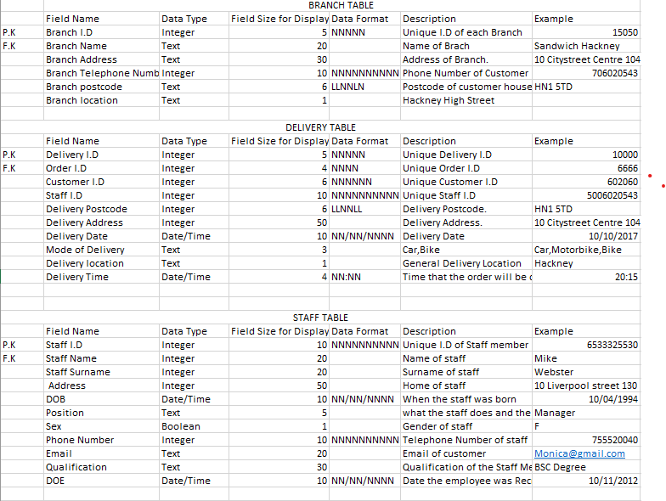

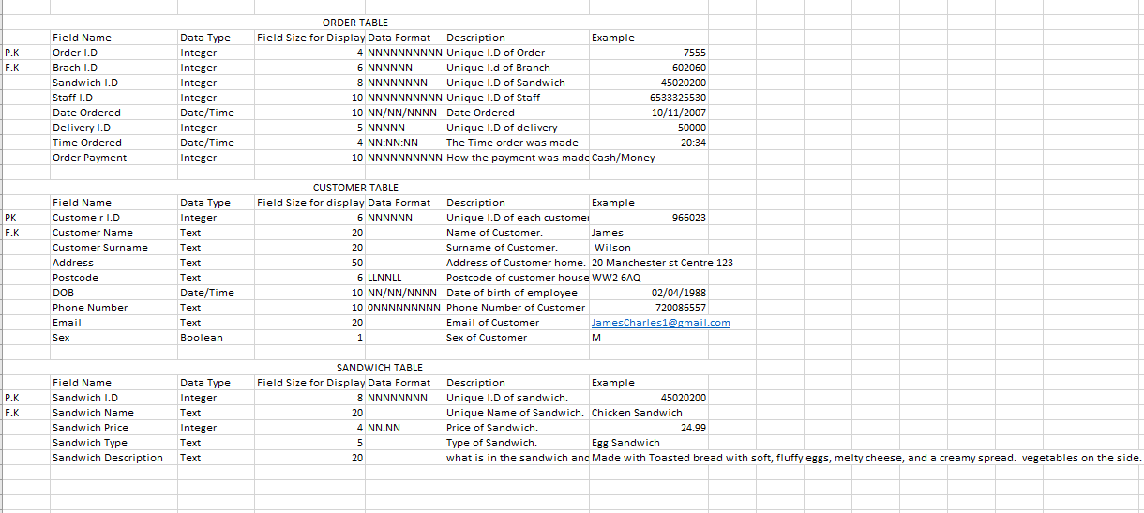

|  |  |  |
| --- | --- | --- |
| Task | Start Date | End date |
| Meeting | 10/12/2021 | 12/12/2021 |
| Research | 15/1/2022 | 25/1/2022 |
| Design proposal | 27/1/2022 | 27/1/2022 |
| Implementation of design | 1/2/2022 | 7/2/2022 |
| Creation of queries, forms and reports | 15/2/2022 | 28/2/2022 |
| Final Designing | 1/2/2022 | 5/2/2022 |
| Testing | 15/3/2022 | 21/3/2022 |